DESIGN DOCUMENTATION OF MUNICIPAL COMPLAINT SYSTEM

1.USE CASE DIAGRAM: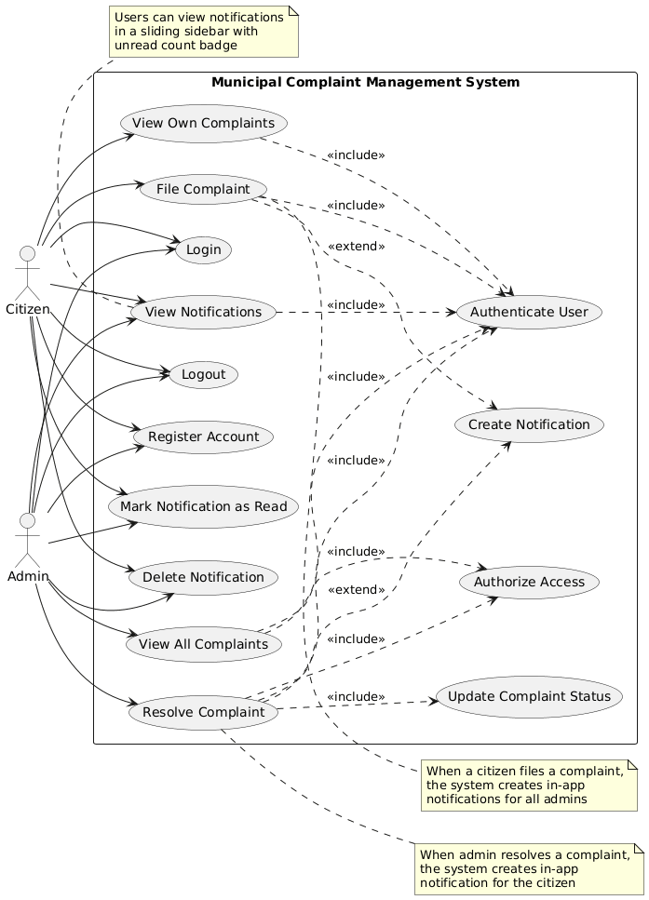

2.CLASS DIAGRAM:
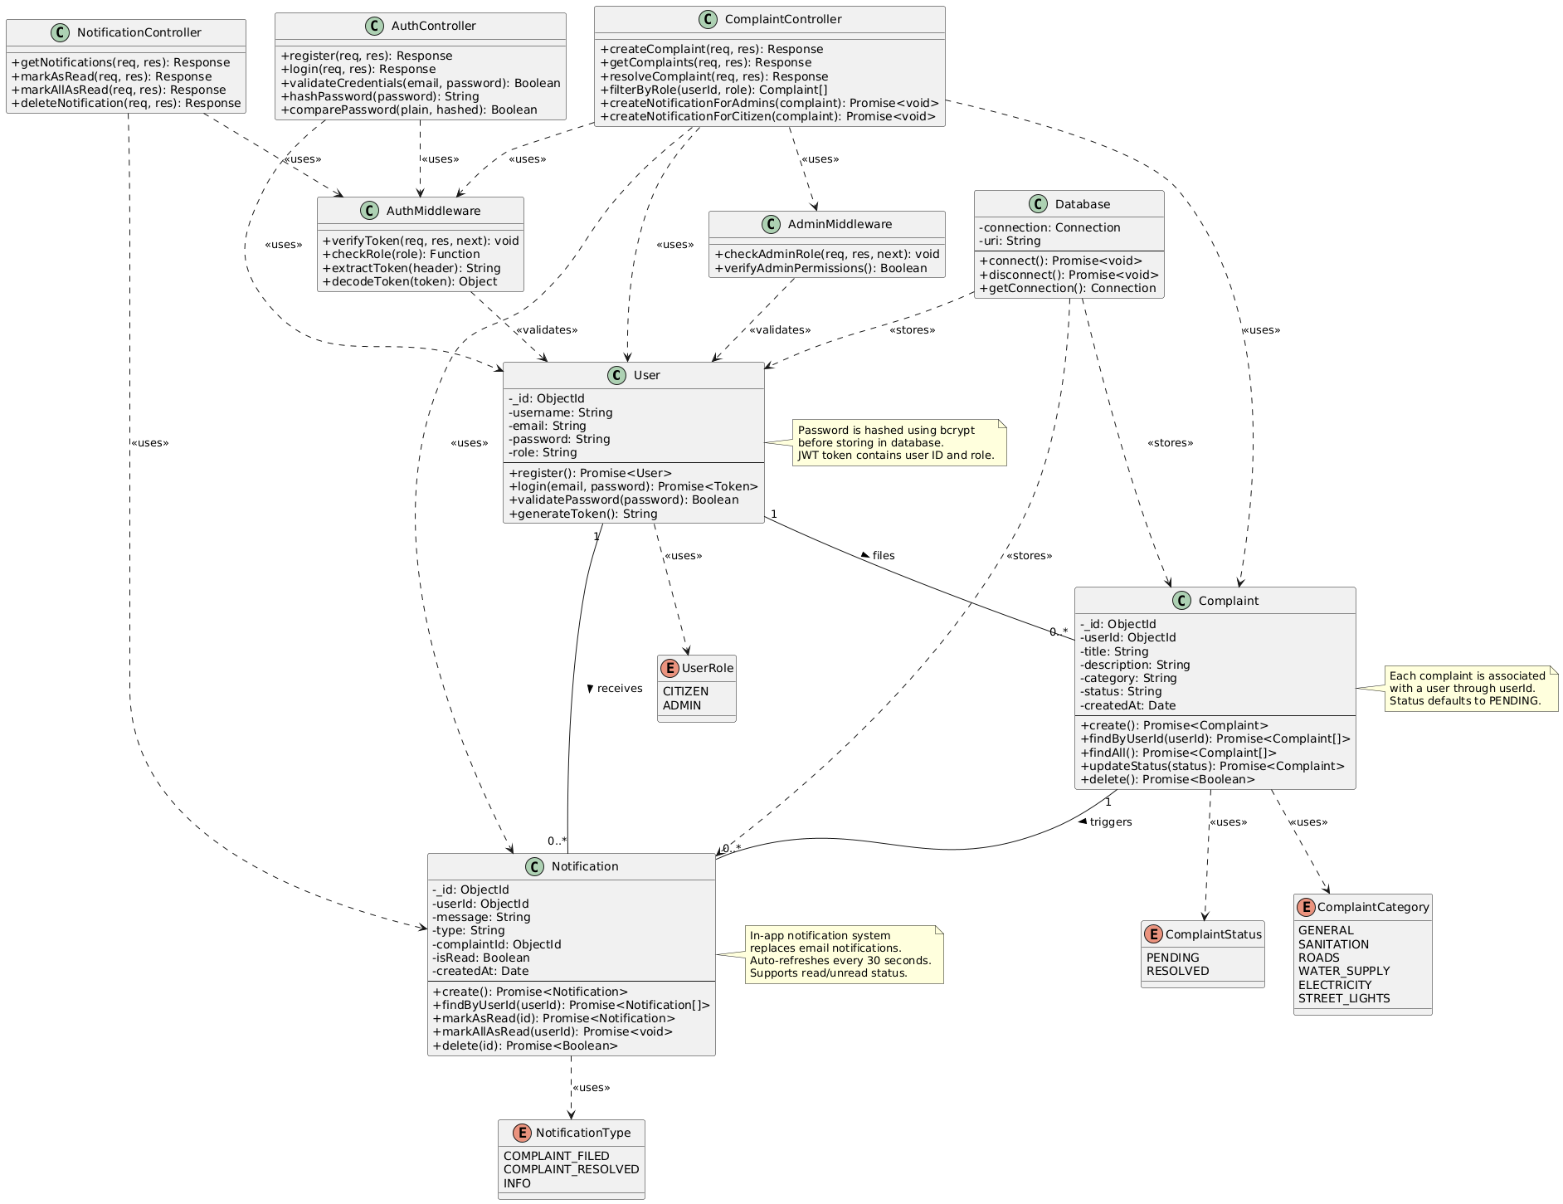

3.SEQUENCE DIAGRAM(REGISTER AND LOGIN):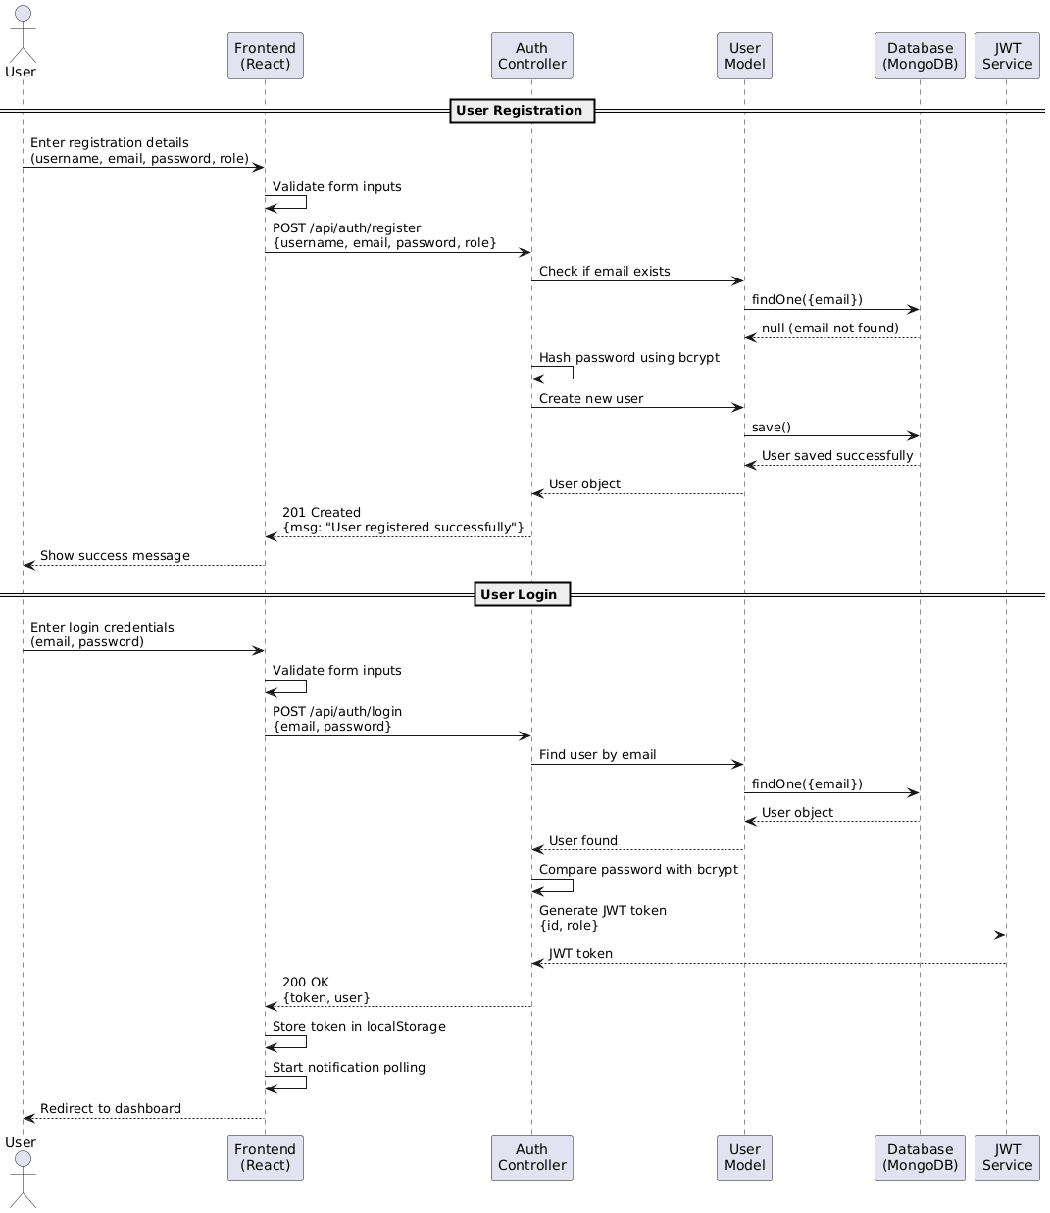

4.SEQUENCE DIAGRAM(FILE COMPLAINT):
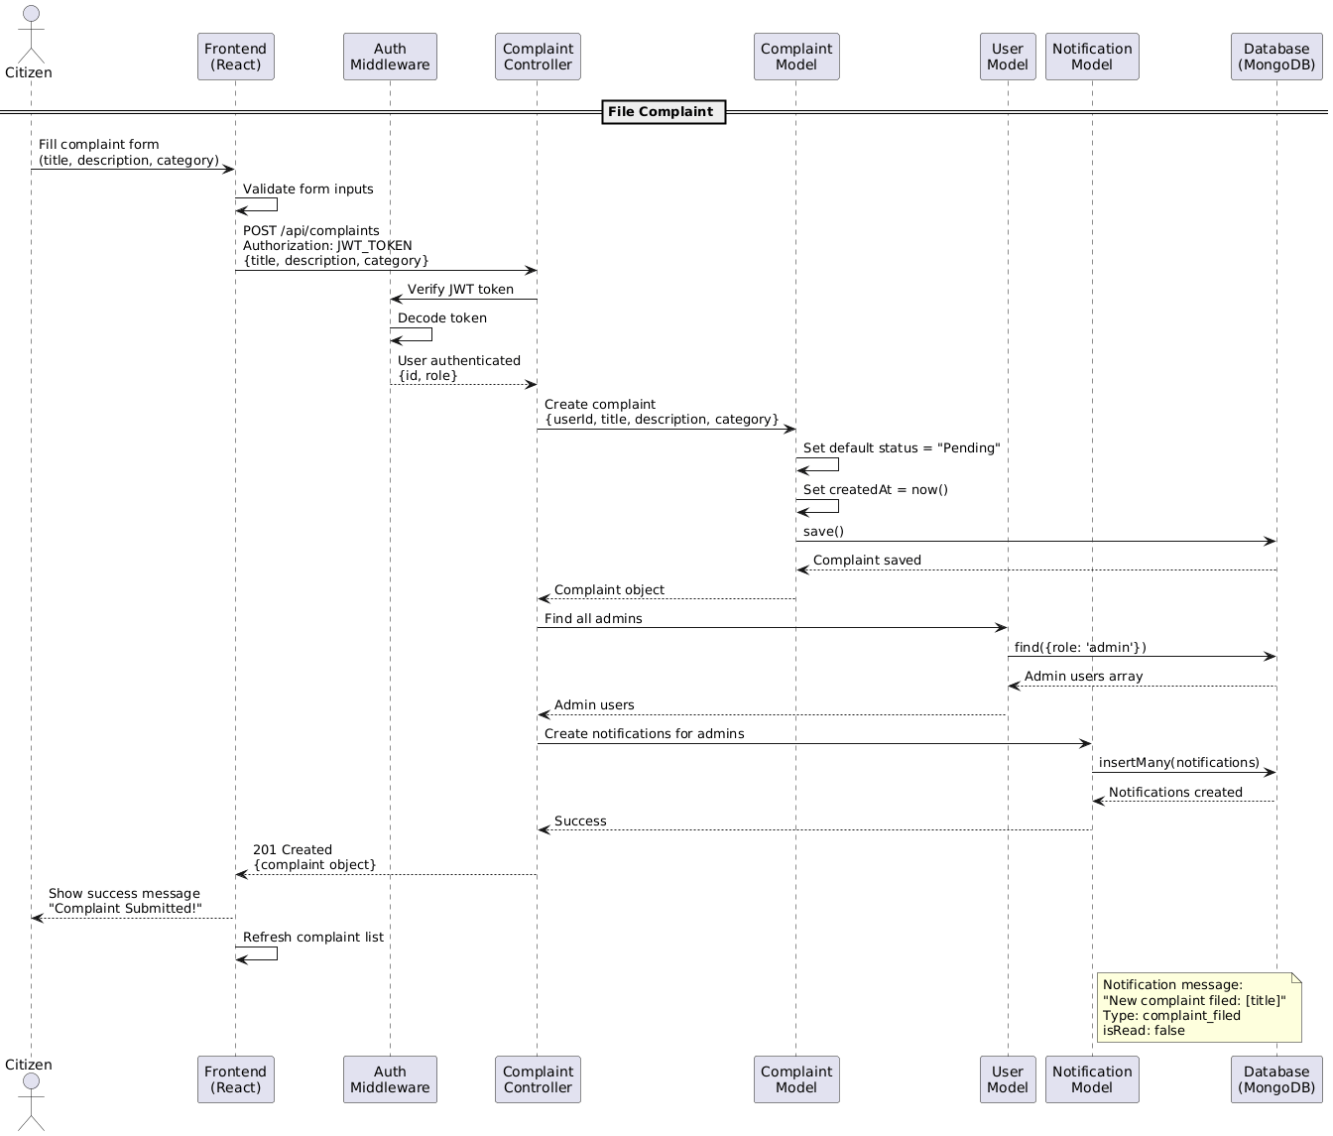

5.SEQUENCE DIAGRAM(RESOLVE COMPLAINT):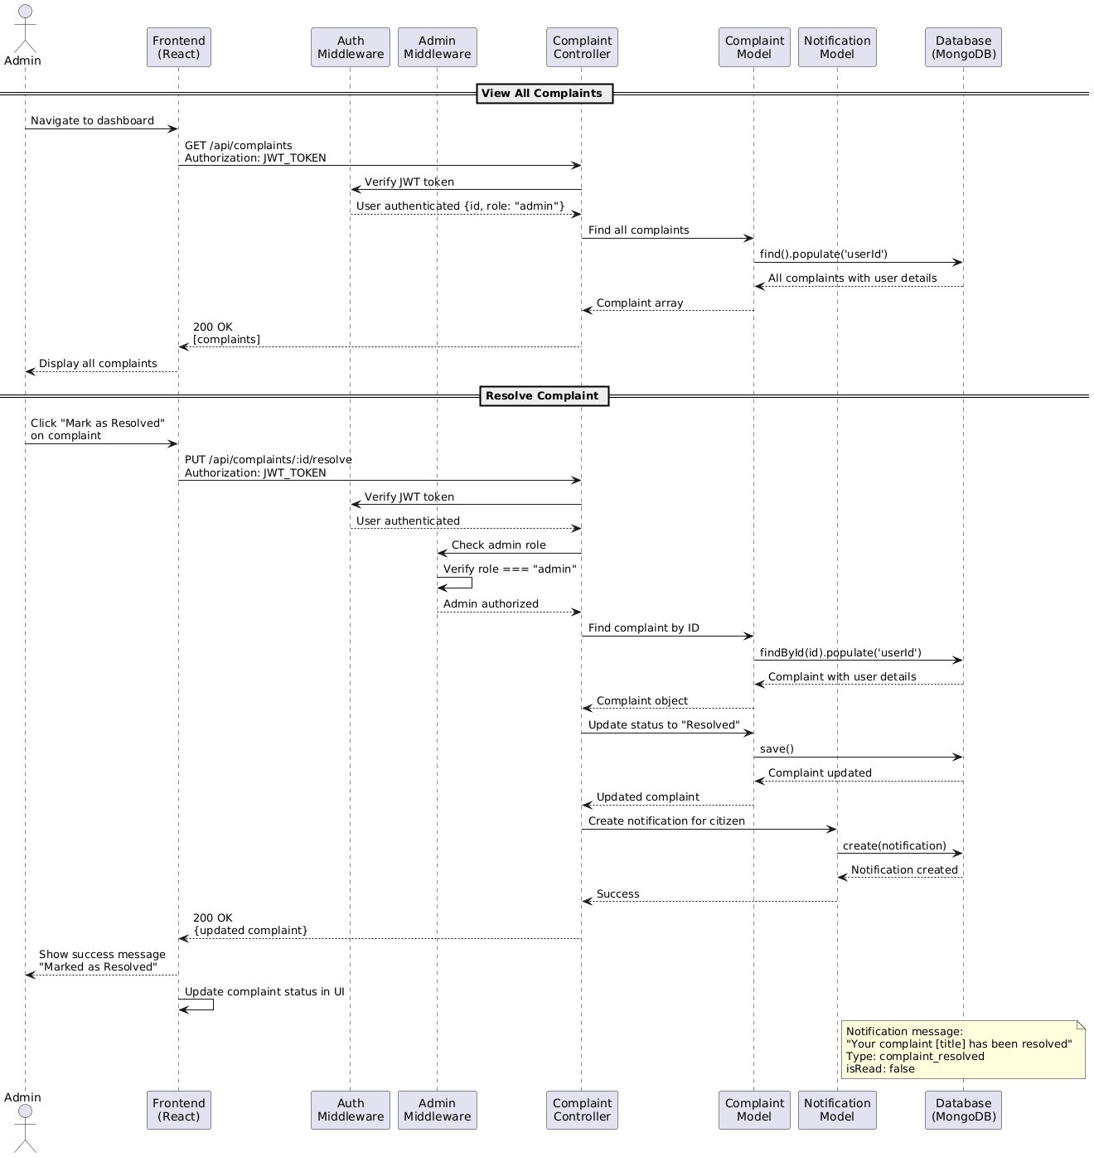

6.COMPONENT DIAGRAM:
